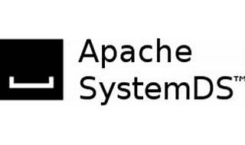



Explore

[**Apache SystemDS** is an open-source machine learning (ML) system that covers the entire data science lifecycle, from data integration and cleaning to feature engineering, efficient local and distributed ML model training, and deployment](https://systemds.apache.org/) [1](https://systemds.apache.org/). Here are five free reference links where you can learn more about it:

1. [**Apache SystemDS Official Website**](https://systemds.apache.org/): Explore official documentation, installation guides, and examples.
2. [**GitHub Repository**](https://github.com/apache/systemds): Access the source code, contribute, and find community discussions.
3. [**PyPI (Python Package Index)**](https://pypi.org/project/systemds/): Learn about Python bindings and system abstractions for SystemDS [2](https://pypi.org/project/systemds/).
4. [**Wikipedia - Apache SystemDS**](https://en.wikipedia.org/wiki/Apache_SystemDS): Detailed information on SystemDS, including its features and use cases [3](https://en.wikipedia.org/wiki/Apache_SystemDS).
5. [**SystemDS Quick Install Guide**](https://systemds.apache.org/): Get started quickly with installation instructions and environment setup.

Feel free to explore these resources to deepen your understanding of Apache SystemDS! 🚀📚